**Platform:** mblock5

**Extension:** BrainCoHand.mext

**Hardware Requirements:** BrainCo Stem Kit

**USAGE**

Download mblock5 PC software.

After download, drag BrainCoHand.mext into the software.

Enable the **upload mode** to begin programming.

Connect to the hardware by choosing the correct USB port.



Here is an example working with the hand



Working with the extension builder

<https://ext.mblock.cc/?blogpost#/login?r=/exts/device>

username: [Christine.sjx@gmail](mailto:Christine.sjx@gmail).com

password: mblock123

create your own blocks like this:

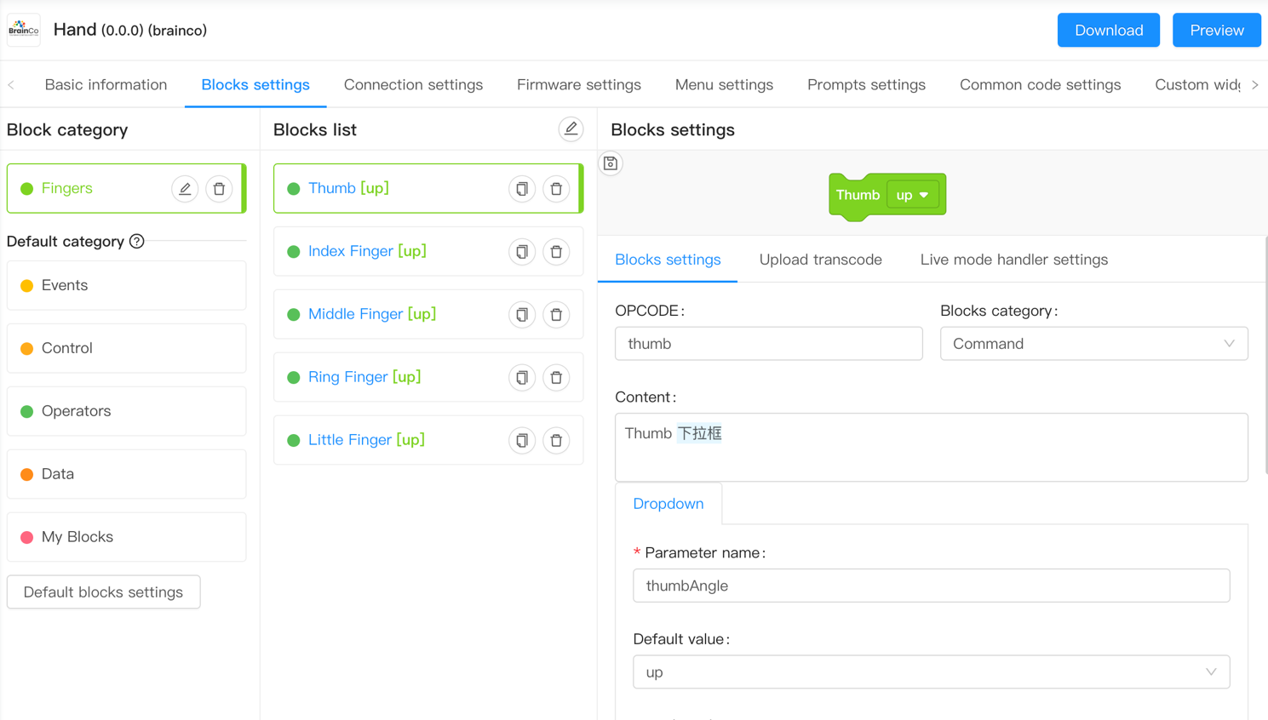

You can follow the official instruction

<http://www.mblock.cc/doc/zh/developer-documentation/developer-documentation.html>

Here are extra attentions:

Based on the above image, for upload transcode, add required library:

<Servo.h> <SoftwareSerial.h> <Wire.h> <Arduino.h>

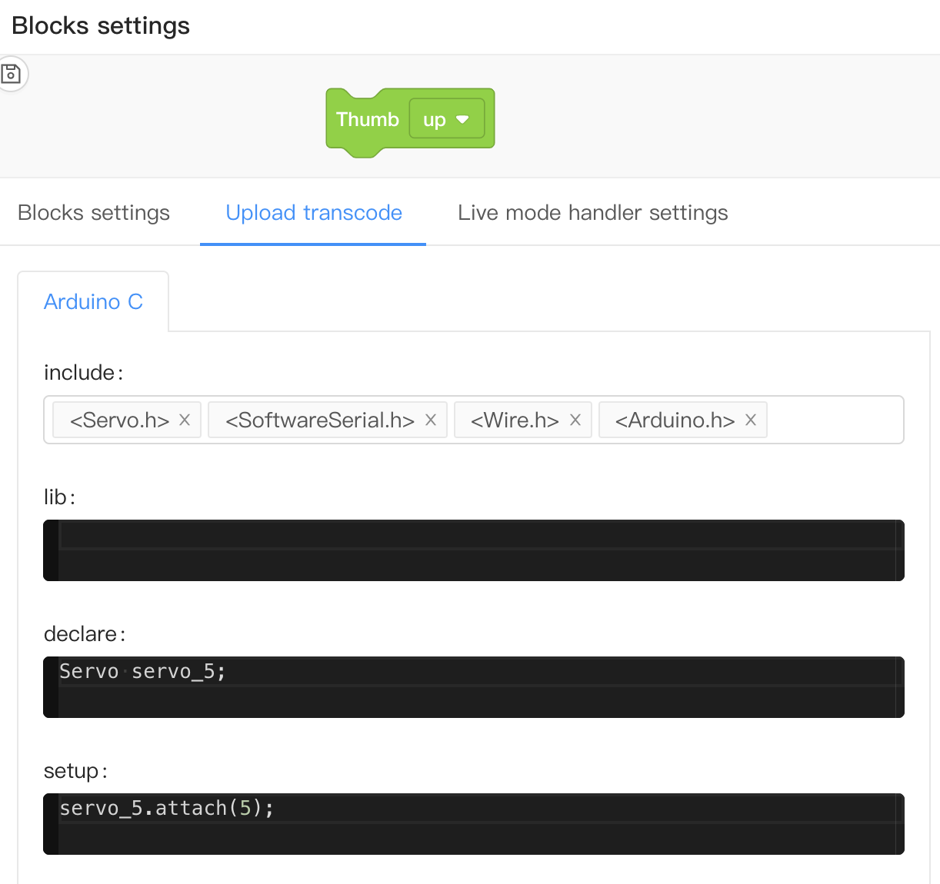

Every customized block should be added into the translation setting in Chinese and English

